Nathan Doan

Professor Kemper

PHYS121L Sec. 4

16 February 2024

**Sample Calculations**

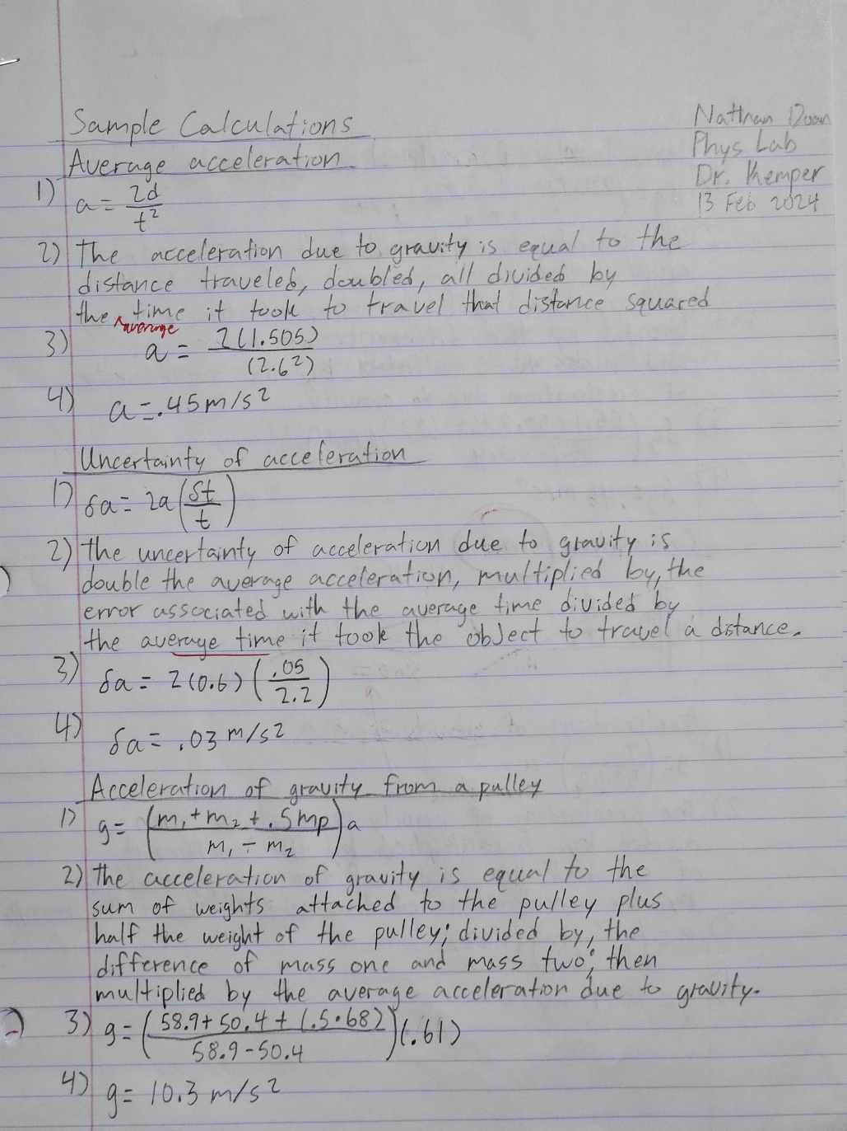

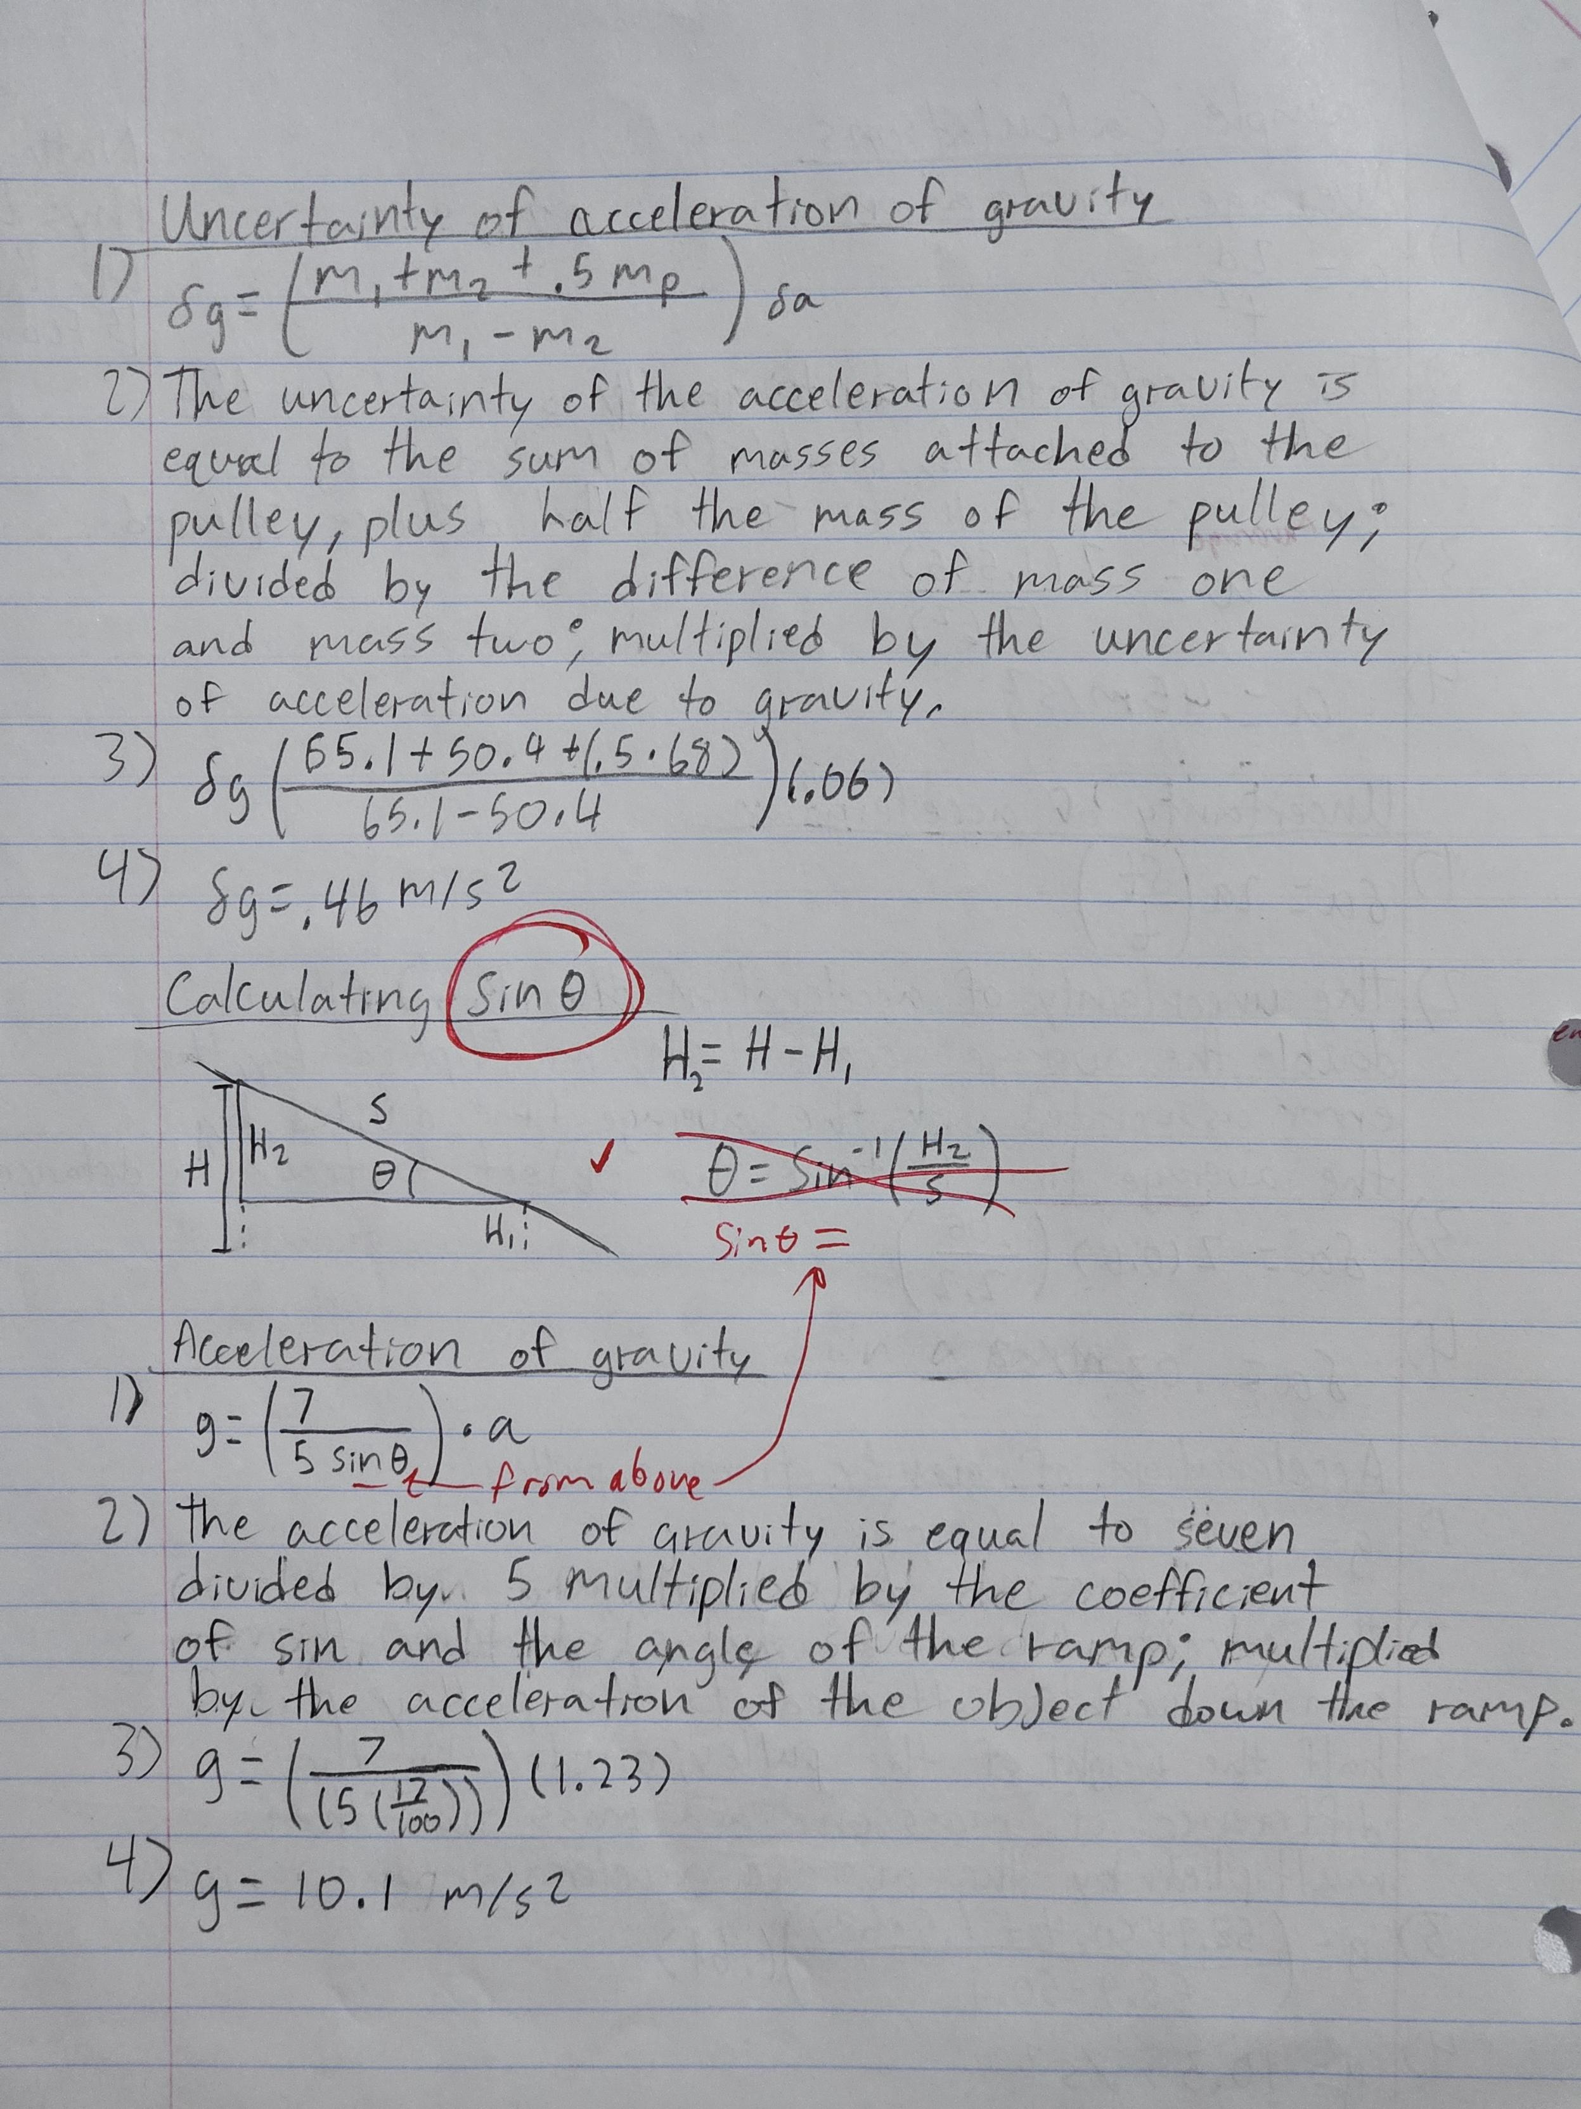

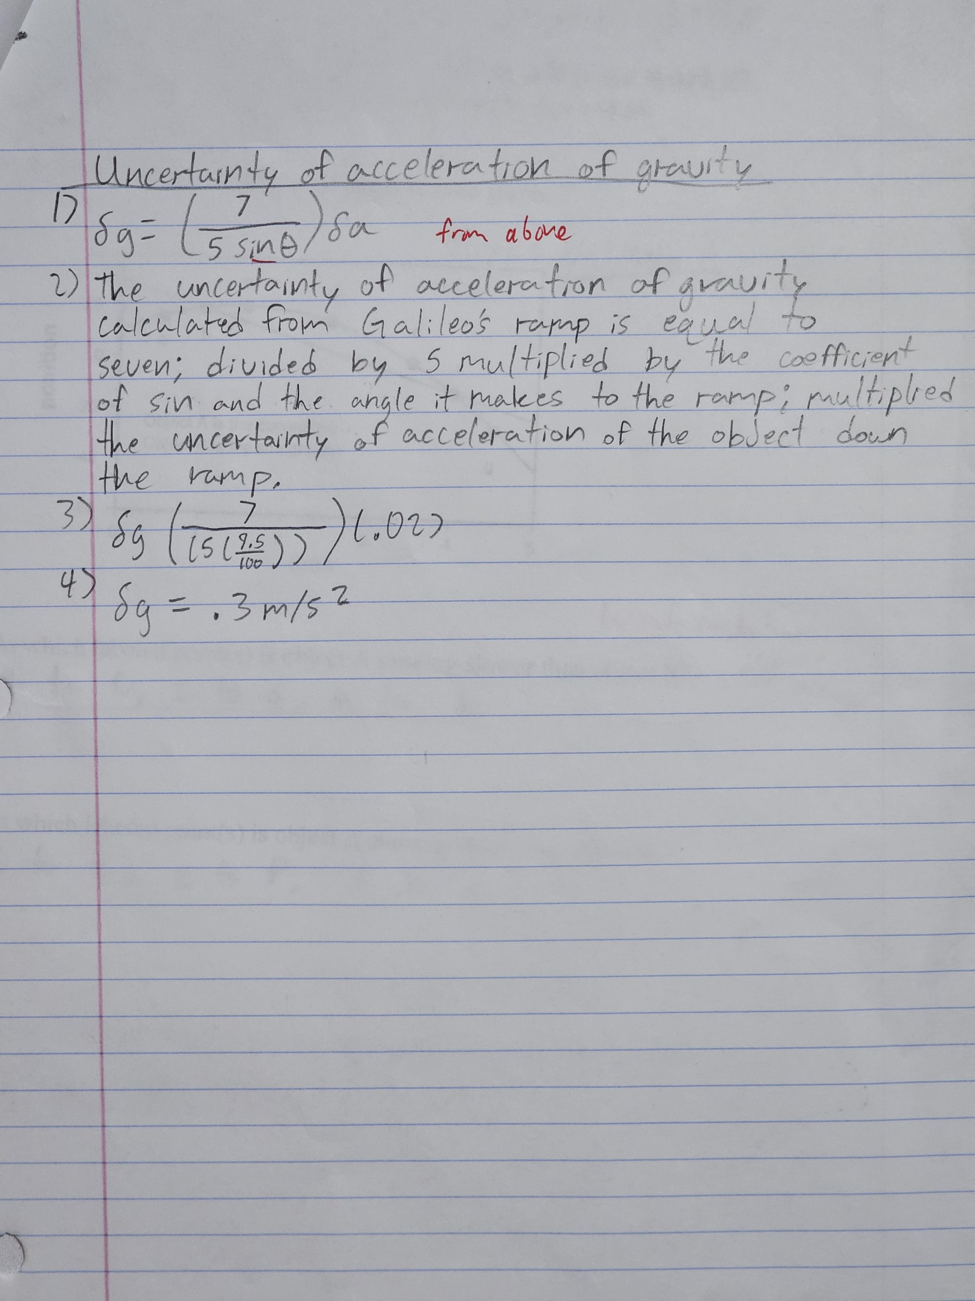

**Challenge**

By using equation 11 in the handout, we calculated a predicted mass (m2) so that another mass (m1) could travel 1 meter in 2 seconds. Firstly, we used the acceleration formula (equation 24) and found the acceleration needed to be .5 m/s^2 for the object to travel 1 meter from rest in 2 seconds. Then, assuming the acceleration of gravity on our masses was 9.8 m/s^2, m1 is 50.4 grams, and the pulley is 68 grams, we can use the gravity formula (equation 11) to solve for m2. Solving for m2 yields 57.6 grams.

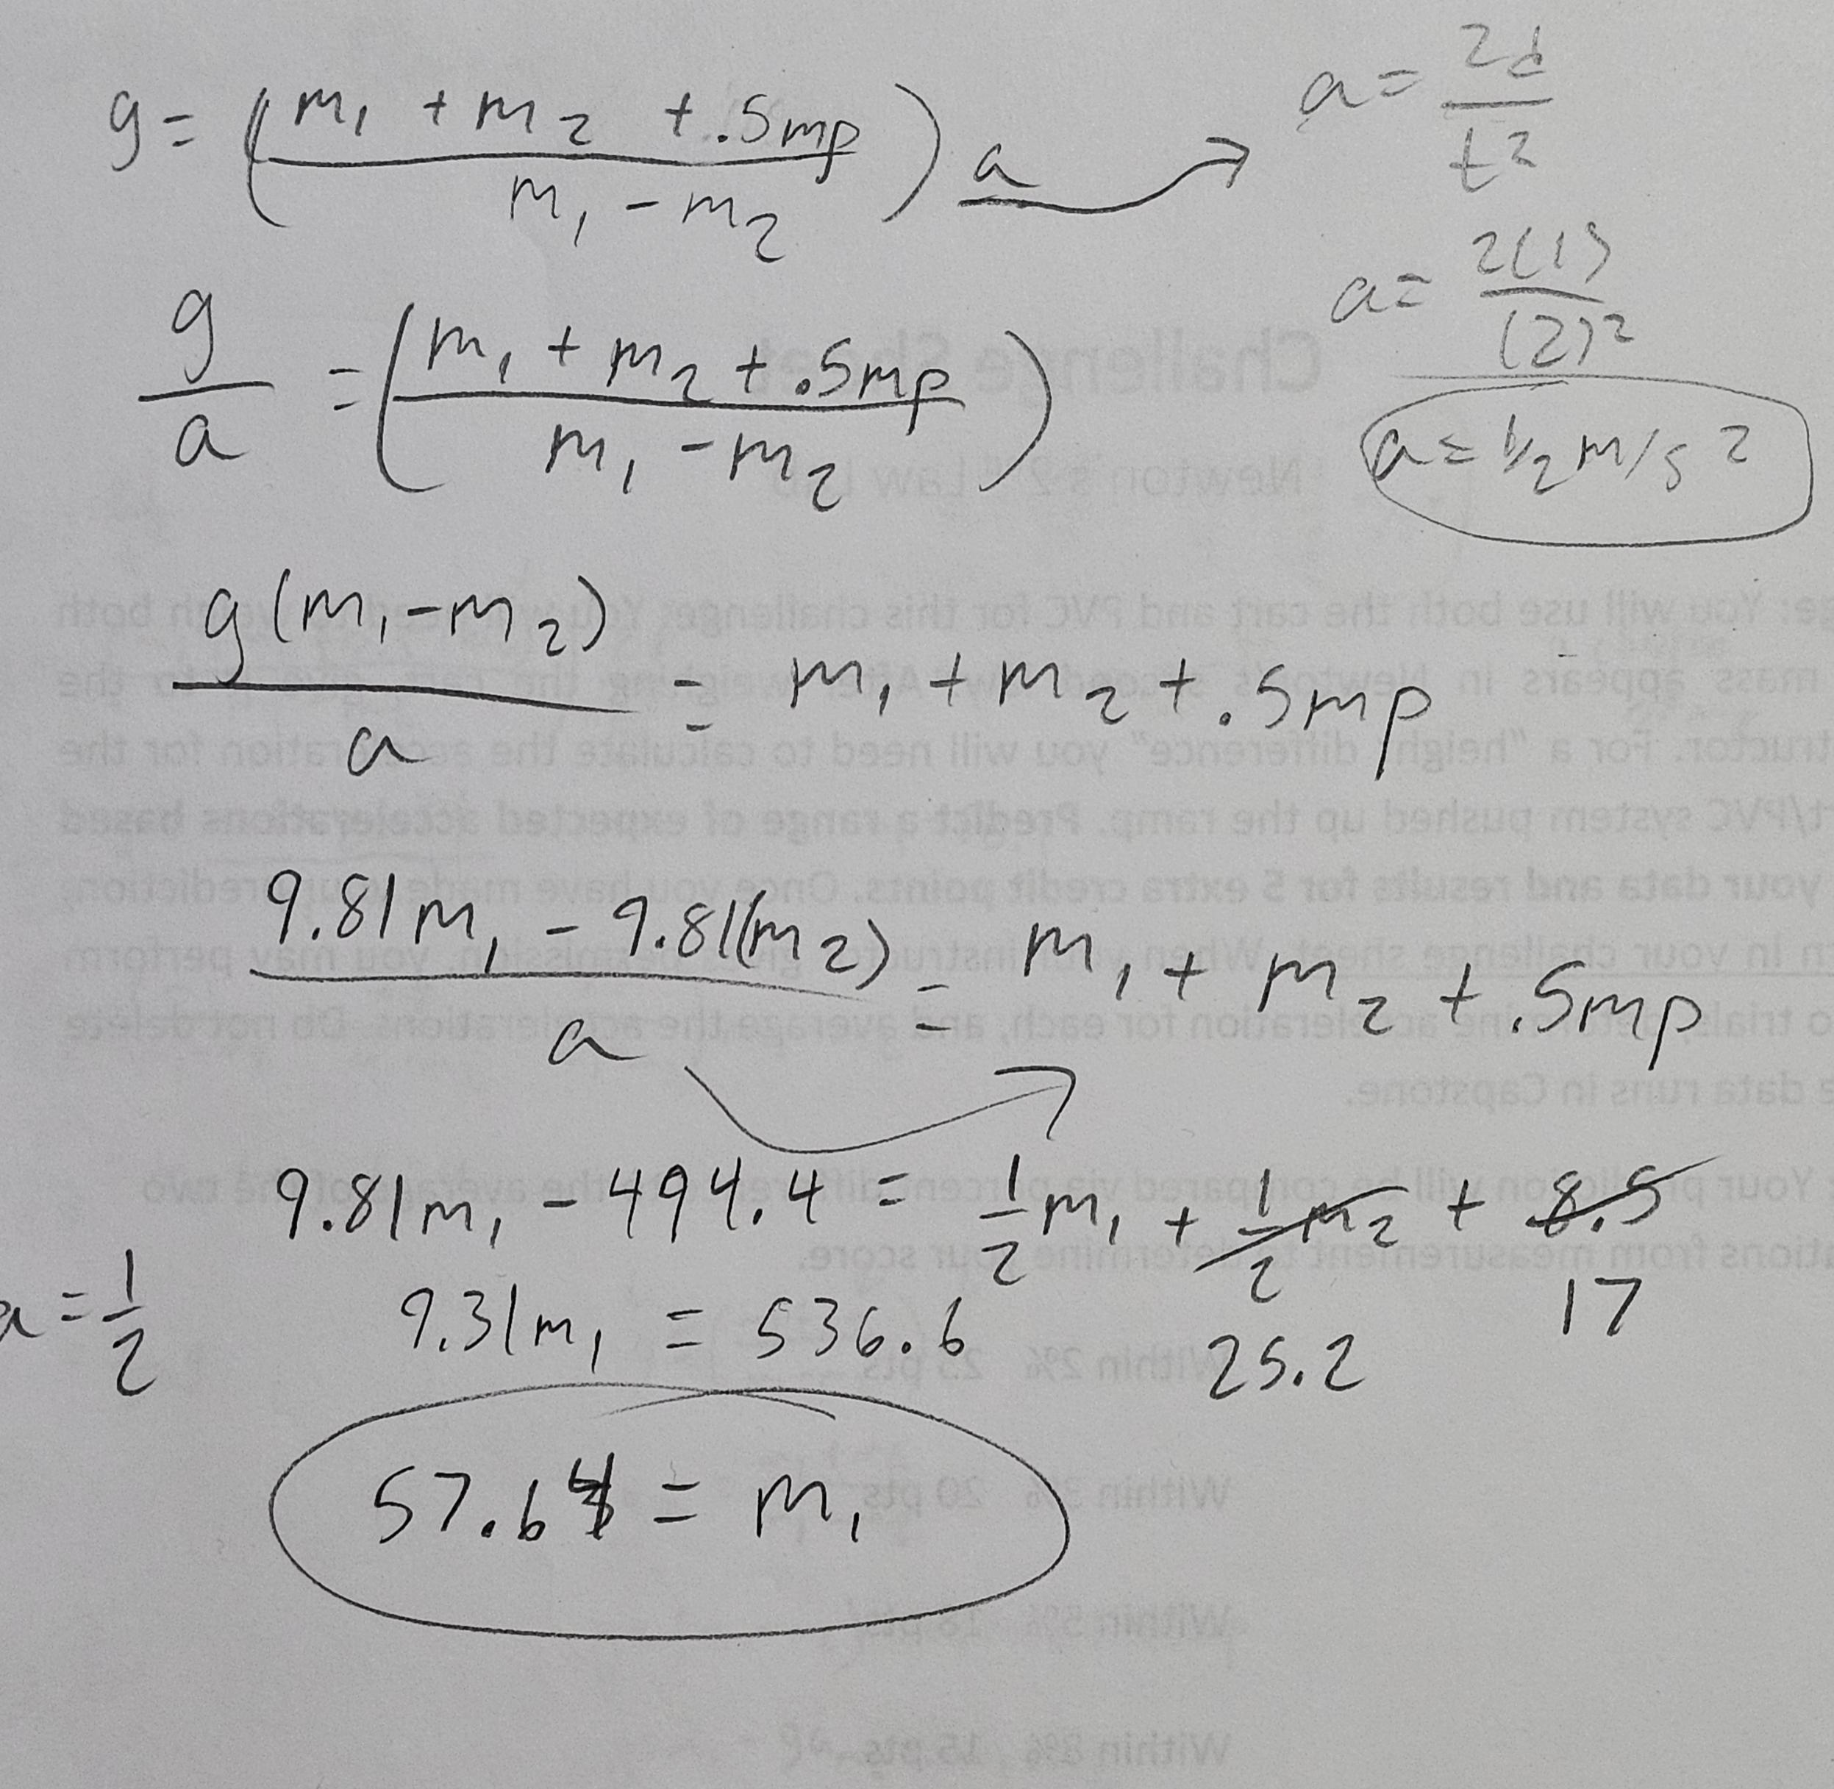

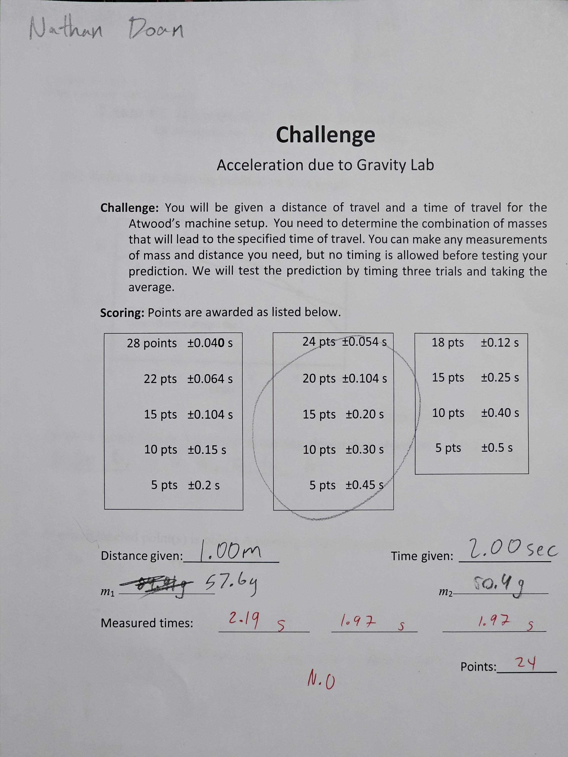

**Discussion**

1. If your results do not agree with the standard value of g, which type of error is responsible? (5 pts)

* Some of our results did not agree with the standard value of gravity. The error that caused the disagreement was from systematic error as we did not account for the weight of the pulley when calculating the acceleration of gravity.

2. If the ramp were frictionless, how would it change part 2 of the lab? Would equations 20, 21, and 22 still be applicable or would there be a significant systematic error? (5 pts)

* If the ramp was frictionless, the ball would slide down the ramp instead of rolling. This would indicate that the acceleration on that ball would be constant. This would affect the equations 20, 21, 22, because if the ball had rolled instead of slipping, we would have to factor the inertia of the ball’s rolling momentum due to static friction. But as the ball is slipping (therefore, no static friction is affecting it), no torque would be produced, therefore affecting the equation of calculating gravity. Systematic error would be significant as repeated trials will yield incorrect results.

3. If you neglected friction for your Atwood Machine, would friction be a source of significant error? Look at your 4-line summaries and your data to answer this question. Which type/types of error would friction cause: systematic, random or reading error? (5 pts)

* Friction was neglected during the Atwood Machine trials. Friction was a significant source of systematic error, at the string was able to “grab” the pulley and use its inertia to affect the time it took a mass to travel a set distance. Friction would have caused a systematic error as no number of repeated trials would have an agreement between prediction and result.

4. List only the significant reading errors from this lab; if there are none, give that as your response. See calculations step 6 above. To tell if reading errors are significant for measurements you only made once, you can copy your Excel sheet and then, one measurement at a time, add or subtract the reading error from the values. If your 4-line summary’s Result’s “best estimate” changes by more than the uncertainty, the reading error is significant. You can apply this to the distance, height, and mass values from the lab. (10 pts)

* There was no source of significant reading errors during our trials. Looking at the reading error of distance traveled +/- .001 meters, the reading error had no significant value change on our acceleration compared to our uncertainty. Looking at the reading error of time +/- .01 seconds, the reading error had no significant value change on our acceleration compared to our uncertainty. Finally, looking at the reading error of the weight +/- .1 grams, the reading error had little significant change on the value of gravity. Because our best estimates did not change more than the value of our uncertainties, we can conclude that reading errors had no significance in this lab.